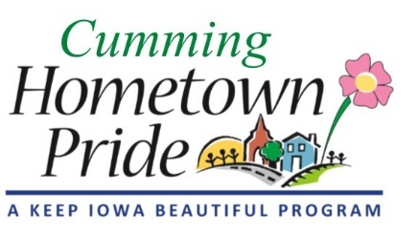
MINUTES
Cumming Hometown Pride
January 6 at 6:00 pm
City Hall

Present: Lorin, Shaunda, Pat

December Minutes: ?

Yard of the Month: Will do this from May – Sept. Need to make 2 signs, but we will only award one per month (2nd is an extra one). Angie will put info in the April city newsletter.

Public Art: Pat reviewed the Call to Artist document. Items to be added: a picture and measurements of the water tower, Hometown Pride logo, City logo, URL address, Pat’s contact info. Lorin will send it to the Warren County group. Shaunda will submit it to the IA Arts Council website. Pat will send it to the 3-4 individual artist names he has received. Angie will post the document on the city website so the link can be used.
Grants that should be submitted – Prairie Meadows, Warren Co Philanthropic, Dept of Cultural Affairs, & Warren Co Economic Development

Trail Signs: The signs will be installed by the city in the spring along with other city signs.

Grant Workshop: January 13 @ 5:30pm

Spring/summer projects: Need to start brainstorming ideas

2020 Christmas light displays: Start talking now, or this spring/summer about ideas

Next meeting: February 3 at 6 pm
Pat will be out of town from Jan 21 – mid April, he may be able to participate in meetings via conference call.

