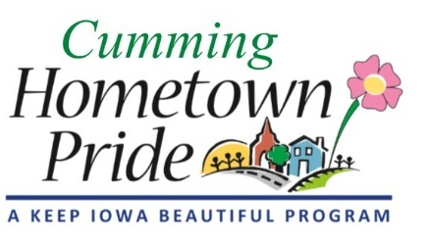
MINUTES
Cumming Hometown Pride
October 5, 2020 at 6:00 pm
Via Zoom

Present: Natasha, Shaunda, Lorin, Craig, Pat

September Minutes: No changes, approved

Merchandise Update:
Natasha will pick up tall koozies on Wednesday.
Pat talked with Angie about the city setting up PayPal or Square for online orders. Angie & Pat will talk to Bob (City Admin). City Council may need to pass a resolution.
Business Sponsorships – decided to not pursue those right now. Maybe at a later date for our next project or event.

Oct. 10 Mural celebration/recognition: The ribbon cutting event will be held on October 10 at 9:30am. Craig will MC and write a short speech to send to committee for input. Craig has a portable speaker and microphone he will bring if needed. Members please be there at 9:15am.

Friday at the Farm update: For Friday night, Craig & Natasha will set up. Shaunda & Pat will take the 2nd shift.
For the farm’s Fall Fest on Saturday, we will NOT make/give away popcorn. Decided it was too much work and about $80 out of our budget we didn’t need to spend. Saturday setup – Craig & Pat, 2nd shift – Natasha & Shaunda

Welcome bag deliveries: There are 3 new residents to deliver bags to.
Shaunda will deliver to 230 N 34th St
Theresia will deliver to 277 and 337 N 35th St

October YOM: Nominations will be due Oct. 22 for Halloween decorated yards

New Business: Pat asked if the committee would be interested in partnering with the Park & Rec Board regarding Christmas decorations for the city. The committee agreed. Pat will reach out to John (P&R Board) to as if they need help going through the old/existing decorations to possibly repair and maybe get ready for next year.

Lorin reminded us that nominations for CHTP officers should be voted on at the November meeting.

Next meeting: November 2 at 6:00pm via ZOOM or at City Hall

