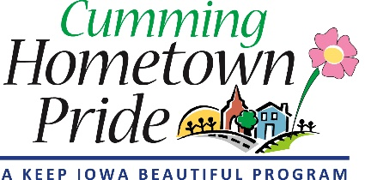

AGENDA
Cumming Hometown Pride
Feb 6. 2020 at 6 pm
Cumming City Hall

1. Review January Minutes

2. Public Art (40 min)
- Water Tower
  - Artist Bids (5 Total)
  - Budget - City funding, Hometown Pride Allowance, Fundraising
  - Grant applications – In Process (GroWarrenNow, Paint Iowa)
  - Grant Applications – Applying for
- City Entry/Bike Trail Art Sculpture
- Hilde DeBruyne
- Warren County Philanthropic Partnership Large Project Grant

3. Optional Projects to Discuss (5 min)
- Downtown Flowerpots

4. Welcome bag delivery (1 min)

5. Committee member announcements/ideas (5 min)

