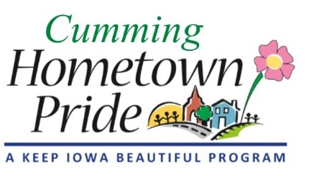
MINUTES
Cumming Hometown Pride
February 6 at 6:00 pm
City Hall

Present: Natasha, Shaunda, Lorin, Craig, and Pat via phone

January Minutes: No changes

Public Art: We had 5 artist bids submitted for consideration. Had lengthy discussion regarding all 5, which ones we liked, pros/cons. The top three were Ben Schuh, Jordyn Brennan, and Samantha Goss/Don Gratzke. We liked Ben the best, but he was also the most expensive. We decided to present Ben Schuh as our top choice to the City Council because he is a proven artist and is willing to work with us to use future fundraising as part of the funding. We would recommend him, showing how the city would need to provide $24,250, with potential offsetting future fundraising income. If the city doesn’t want to contribute that much, we would recommend Jordyn Brennen as our second choice.

Pat is going to talk to Ben to see if he would lower his fee at all. Pat will call Ben & follow up with group.

We will apply for the Prairie Meadows Community Betterment Grant (due 2/28), the Warren County Economic Development Corp Grant, and the Warren County Philanthropic Partnership Grant.

Shaunda will work on the Prairie Meadows grant and Natasha will work on the two Warren County grants.
Drafts will be sent out via email for committee members to review/proof before submitting.

We did not have time for the remaining agenda items.

Next meeting: March 2 at 6 pm

