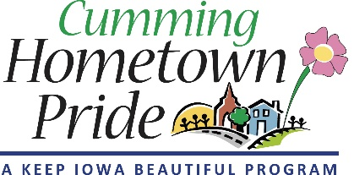

Cumming Hometown Pride
Meeting Minutes
February 16, 2022

- Attendance: Angie Cooper, Renee Highfill, Lorin Ditzler

- Banner updates:
- We will submit an application to Warren County Philanthropic Partnership to pay for 7 additional banners and the cost of installation.
- Pete at Capitol City Construction Co of Indianola quoted $750 to install 7 banners (update: quote for 15 banners, if we receive the grant, is $1100)
- We will request permission from MidAmerican now for the first round of banners. We have 7 banners sponsored, and at our last meeting we chose 7 locations. We decided we would like to ask for permission for a few extra poles in case more sponsors come in or one of the poles doesn’t work. We identified 4 additional locations. We will run this by the city and the rest of the group first before submitting to MidAmerican
- Lorin will make an updated map that includes the original and added locations, and pair it with pictures of the poles so that there is no confusion. Renee mentioned that the poles also have id tags with numbers, and she can gather those if it’s needed.
- Angie will take care of the MidAm application. She will get the insurance information from the City and fill out the application.
- Renee is going to follow up with HyVee about their sponsorship and is going to ask Kyle at the Distilling company if he would want to sponsor the banner next to his place.
- Lorin will ask Angie and Jessica if there is an upcoming newsletter where we could put a “last call” for sponsorships.

- Officers: Renee has agreed to be co-chair (with Sarah) for 2022.

Next meeting – March 16, 2022

