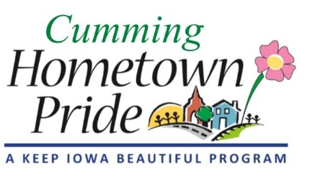
MINUTES
Cumming Hometown Pride
June 1 at 6:00 pm
Via Google Meet

Present via video call: Natasha, Shaunda, Lorin, Craig, Pat, Janeen Eastwood

May Minutes: No changes, approved

Water tower project update:
Design was sent to council and waiting for approval of design & sign contract. Need to use CHTP 2019-20 funds before June 30.

Sign Installation: Still waiting for city to install

Fundraising:
Pat will talk to Ben about different products. Which ones sell well? Shaunda offered to talk to Distillery about selling products and/or sponsorship (when we get to that point). Natasha offered to work on a sponsorship brochure/flyer and talk to various city businesses/vendors.
Lorin is to ask Angie what our account balance is.
The question was raised if the CHTP should establish a separate bank account or set up as a 501c3? Decided not to do a 501c3 and to ask the city to establish our own bank account to separate any potential fundraising funds and expenses.
Fridays at the Farm (starting June 19) would be a good venue to promote CHTP and to sell fundraising items. Will need to decide dates committee members can “man a booth” (should have 2 present). Suggested maybe once or twice a month.

Warren County Courthouse Banners:
Banner will be $75 and Lorin will design and get an image from Ben of the water tower design to use.

City Website Cumming HTP Posts:
Need to think about/look into using our website to sell shirts/products or to ask for donations (similar to the Norwalk HTP)

Next meeting: July 6 at 6:00 pm

