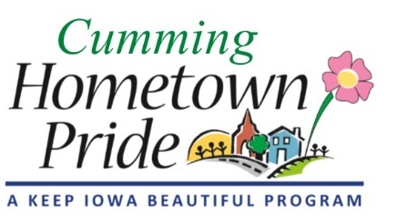
MINUTES
Cumming Hometown Pride
August 3 at 6:00 pm
City Park Pavilion

Present: Natasha, Shaunda, Lorin, Craig & Lisa Olson, Pat, Sarah Webster

July Minutes: No changes, approved

Water tower project update:
Project was approved by city council. As of the meeting, Ben was mostly done with painting.
The license agreement has been reviewed by both lawyers and has been sent to be approved by city council at next week’s meeting. They need to choose to either 1) pay $7500, OR 2) do a 50%/50% fundraising profit split with Ben for the next 5 years (up to $10,000). The committee supports option #1.

Now that the painting is completed, we need to follow up with the 2 grant donors for what supporting documentation is needed (i.e. proof of payment, receipts, etc). Natasha will ask Angie what the city has for proof of payment to Ben.
Lorin will check on what was written in the grants for how we were going to publicly recognize the grant donors.

Community Party/Unveiling Event – need to set a date, look at a Sunday afternoon in early October, or on a Friday afternoon just before the Middlebrook Fridays on the Farm. (Want to avoid Saturday football games, if they happen)
Pat will reach out to the Park Board to coordinate with them or avoid conflicts. Not sure what we CAN do during the pandemic. Would invite city council, Ben and wife, grant foundation representatives, public, media, and other Hometown Pride groups.

Sponsorships – ideas to give with a donation - a framed, signed poster or a plaque with their name & water tower image (for highest giving level)

Fundraising:
Fridays at the Farm – we set up a table/booth last Friday to solicit committee volunteers and donations. Got one donation pledge and 2 volunteers. Will continue to do this each week thru August and then determine after that.

Shirts/Other Items Quote – Natasha is reaching out to several vendors for printing items (shirts). Lisa Olson suggested we focus on how many things we want to sell and have different price points. After much discussion, the committee talked about the following ideas: Polar (insulated) 24oz water bottles (it is a water tower after all!), can koozies (skinny and normal), t-shirts, posters, pint drinking glasses, shot glasses. We will initially focus on water bottles, t- shirts (good quality) and posters/prints. We decided NOT to do bike jerseys for now as those are quite expensive and would need both men’s/women’s sizes. Let’s see how the other items sell first.

Pat will ask council next week if they can pre-authorize a general disbursement amount limit that the Hometown Pride committee can spend for fundraising purposes. To avoid having to wait until the next council meeting to get approval each time.

Yard of the Month: Had 5 nominations and decided on 130 N 34th St (Dennis & Karen Dissinger) and 212 N 44th St (Teresa Carr)

City Council: Pat will put together a presentation for the meeting –
- Licensing agreement recommendation
- Unveiling event
- Fundraising & authorization
- Cost update

Committee Best Practices Moving Forward: Don’t include Angie on back & forth discussion emails between committee members. Only send her emails when there is a direct question or action item for her.

Committee member announcements/ideas: Be thinking of next projects!
We will have a special meeting after the city council makes their licensing agreement decision so we can proceed with fundraising items.

Next meeting: September 7 at 6:00 pm at City Hall - this is Labor Day, do we want it on Tuesday the 8th or Monday the 14th?

