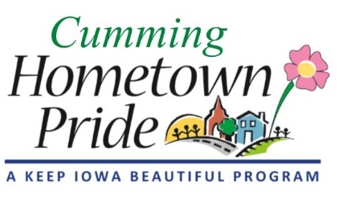
MINUTES
Cumming Hometown Pride
September 7, 2020 at 6:00 pm
City Park Pavilion

Present: Natasha, Shaunda, Lorin, Craig, Pat, Sarah & Ray Webster, Renee Highfill, Theresia Adams, & John M (Park Board member)

August Minutes: No changes, approved
Yard of the Month:
The September winners are Wayne & Heather Lesley at 3050 N Cattail Creek and
Dave & Dee Roach at 3278 110th Lane
There was lots of discussion regarding what boundaries to use for inclusion of our Yard of the Month (YOM) winners.
Natasha made a motion for the boundaries to include houses whose legal postal address is Cumming.
Pat motioned to amend the previous motion to specify that the houses also not be within a different city’s limits. All voted in favor. The final boundary wording is as follows:
Yard of the Month nominees/winners must be a resident/house with a legal postal address of Cumming and not be within another city’s limits (i.e. Norwalk, WDM, etc)

Merchandise Update:
Posters - Pat ordered 12 – 8x10 posters at a cost of about $13 each. We will sell these for $25 each
Water bottles – Lisa Olson ordered 50 at $9.50 each. We will sell these for $20 each. Ordering lead time is about 4 weeks
Koozies – Natasha will be ordering these at a cost of $1.50 and we will sell them for $5.00 each
She will ask Ben for a digital file of just the “I love Cumming” trademark image to put on the bottom of the koozie
T-shirts – Theresia Adams brought shirt samples from Smith Promotions. Natasha brought shirt samples from Broken Arrow. The group decided they liked the Broken Arrow (Next Level 3600) shirt best. Natasha followed up via email (after the meeting) with color options, and it was decided that Turquoise and Light Grey looked the best. Natasha asked Broken Arrow to send her mock images on those color shirts for viewing. There is a price break at a quantity of 72. For 50 shirts, the price is $17.88 each, for 72 shirts, the price is $16.84. We can order any combination of colors & sizes.
Regarding selling the merchandise on the city/Hometown Pride website, Pat continues to talk to Angie. Until we get a credit card method of payment set up, we can only accept cash/check.

Mural celebration/recognition: The ribbon cutting event will be held on October 10 at 9:30am. We will contact the Norwalk Chamber of Commerce if they have a big scissors and ribbon we can borrow. Lorin will contact/invite the Warren county grant givers & the DM Register. Craig will be the event coordinator and invite Ben & the city council. We will have a booth at the Middlebrook Fall Fest (10am – 3pm) to sell merchandise and give away popcorn.

Other Business: City has not installed the trail signs yet. Pat will remind Angie
Next meeting: October 5 at 6:00pm at City Hall

