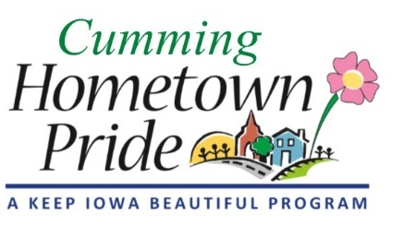
MINUTES
Cumming Hometown Pride
January 4, 2021 at 6:00 pm via Zoom

Roll Call: Pat Whalen, Shaunda Murphy, Lorin Ditzler, Craig Olson, Renee Highfill, Theresia Adams, Angela Cooper (Absolute Repair), Natasha Adams, and Sarah
December Agenda: Approved
November Minutes: No changes, approved

OLD BUSINESS
- Accepting electronic payments update – Pat talked with someone at the state treasurer’s office and got another online payment service option. He continues to research for the best viable option for Cumming. Still a work in progress.
- Christmas Lights – Renee was going to connect with Bob to when taking down the Christmas lights. Also, discuss with Bob how many more power boxes need to be installed for lights if we order more.
- Cumming Newsletter – No monthly newsletter is mailed out per Angie. She sends a newsletter by email to those on the list. The only way to get on that list is to reach out to Angie and let her know you want to be added.

NEW BUSINESS
- 2021 Project ideas
  - Park restroom, bench, or bike rack (Shaunda) – will discuss at Feb meeting – reaching out to John on the Park Board.
  - Welcome to Cumming (Entryway) sign (Pat) – drafted note to send to Angie and City Council members but has not sent yet. Will send to Shaunda for her to send.
  - Painting bike trail (Craig) – Details in email Lorin sent to Craig and explains what Carlisle did. $2000 in materials and labor. Signs along the bike trail – following up with Angie on this one.
  - Spruce up downtown (Theresia) – Benches along main road in Cumming, stone flower garden (pics sent), sculpture, flowerpots – who is going to water them? See about a business sponsoring or adopting a flowerpot to take care of? Maybe do something with the chain link fence by the bike trail along Cumming Rd – putting prairie grass, shrubs, flowers to make it look better. The Legion owns the building and land, so partnering with them to do some sprucing up. Partnership grant – Downtown Facelift – deadline March 1st.

- Fundraising 2021 letter (Renee’s idea)
  - Sponsor a Christmas Light, a tree, a flowerpot, etc.
- Other
  - Coming up with a theme for Cumming and working with a Design Team to give us ideas. Sarah was going to talk with the Legion and The Tap.

Adjourned at 7:02pm
Next meeting: Feb 1st at 6:00pm via ZOOM or at City Hall

