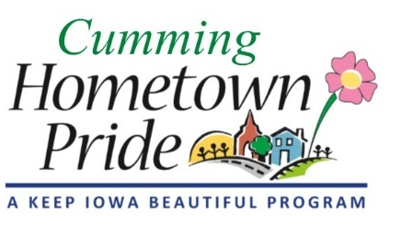
MINUTES
Cumming Hometown Pride
February 1, 2021 at 6:00 pm via Zoom

Roll Call: Shaunda Murphy, Lorin Ditzler, Craig Olson, Renee Highfill, Theresia Adams, Natasha Adams, and Sarah Weber
February Agenda: Approved
January Minutes: No changes, approved

OLD BUSINESS
- Accepting electronic payments update: Pat continues to research for the best viable option for Cumming. Still a work in progress.
- Christmas Lights – Renee was going to check with Bob to see how many more lights we would need and send thank you card for putting up and taking lights down. Add to the Oct. agenda to talk about x-mas lights for the coming season.

NEW BUSINESS
- 2021 Project ideas
  - Park restroom, bench, or bike rack (Shaunda) saying no to the restroom because too expensive and no one to keep it up. Bike repair station was thrown out there for the park, but the Cumming Tap has one behind their bar that they own and free for anyone to use.
  - Welcome to Cumming (Entryway) sign (Pat) – did not discuss
  - Painting bike trail (Craig) - did not discuss.
  - Spruce up downtown (Theresia) – Update the fencing along Cumming road by the Legion and Tap with the same fencing that was put in at Great Western Crossing to keep the same flow. Partner with the Legion to spruce up the grass area on the corner - looking into grant proposal – Sarah is talking with the Legion to see if they would be willing to help and open to the idea so we can move forward with the grant process. Metal Artwork on the light/utility poles throughout Cumming. Williams Machine Shop $275-$375 per banner. Use portion of City money towards the metal artwork on the light/utility poles. Possibly having business or homeowners paying to adopt a sign. Theresia will work with Lorin on the artwork for the banners. Looking at doing the pieces of the watertower prints on the signs and mixing it up between signs. Will need to get permission from the city.

- Grant Opportunities
  - Warren County Philanthropic grant – get bids for fence and landscaping along Cumming road. Sarah is checking with the Legion on specifics on requirements for the fence to meet code. Natasha will post a Facebook post to open up bids on Facebook to Warren County. Shaunda will reach out to Diligent Development to get information on the Great Western Crossing fence. Natasha is willing to help with grant process.
  - New Resident Welcome Bag – 137 N. 35th St. moved in 1/19 – Sarah will deliver welcome bag.
  - Future meetings – City Hall still recommends video meetings, revisit for April or May meeting.
Adjourned at 7:16pm - Next meeting: March 1st at 6:00pm via ZOOM

