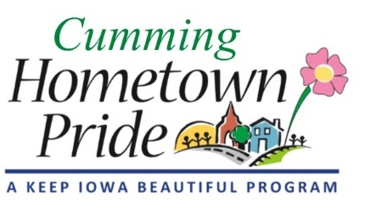
MINUTES
Cumming Hometown Pride
April 14 at 6:00 pm
Via Zoom with Ben Schuh

Present via video call: Natasha, Shaunda, Lorin, Pat

Video meeting was to discuss alternative design ideas with Ben and various other logistic details.

The city council met on 4/13/20 and the city attorney sent contract comments back to Ben.

Can’t start painting prior to July 1 because of the Prairie Meadows grant.

Need to coordinate with city on timing for the base coat and the “Cumming” font size & spacing. Need to verify the contractor will treat the rust properly.

Lorin to contact Prairie Meadows to verify timing & whether Covid-19 has affected grant timing.

Discussed artist’s proposed drawing and other ideas/suggestions.

Ben suggested painting a heart on the sidewalk to the water tower as a suggestion for where to stand for a good photo shot.

Paint will fade, maybe last anywhere from 8-20 years.

Committee will come up with some reference photos to send to Ben.

