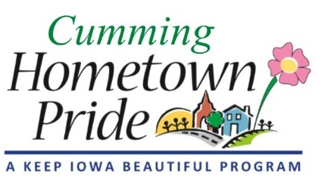
MINUTES
Cumming Hometown Pride
April 6 at 6:00 pm
Via Zoom

Present via video call: Natasha, Shaunda, Lorin, Craig, Pat, Janeen Eastwood

February Minutes: No changes (no March mtg)

Fundraising update:
Grant timelines:
- WCEDC: to be approved at April 22 meeting
- WCPP: End of April/Early May
- Prairie Meadows: July 1
Additional grant to consider: IA Dept of Cultural Affairs Art Project Grant, Deadline June 1
Paint Iowa Beautiful grant: we received 7 gallons of paint
Paint donation – Pat will contact Norwalk HP to set up

Ben Schuh Contract:
We’re waiting for the City to create the contract.
Discussion point: Does the City want us to create our own bank account or form 501c3?
Design: We will schedule a call with Ben to discuss potential changes to design.
Timeline: Pat will draft a project planning timeline for the water tower project.

Yard of the Month:
Start the award in May. Make 2 signs. Award one per month.

Fridays at the Farm:
Schedule to begin May 15, but may be pushed back. They are looking for vendors. Contact Janeen if want to schedule a date or know of someone who wants to participate. janeen@middlebrookfarms.com We can have a table there and do fundraising and promotion of our project. It’s every Friday from 4-7 pm but we can come whichever weeks we like. Set up starts at 2:00pm
Ideas for promotion: Put up proposed water tower image on big boards/banner “Coming this summer…”; Pass out coloring pages with the design; Give out water; sell prints/t-shirts/pint glasses; help recruit volunteers
May 29 – Goat Yoga

New projects:
A banner on the Indianola square that promotes the water tower – will wait until things are confirmed
Installing the trail signs – Pat will follow up with City

Next meeting: May 4 at 6 pm

