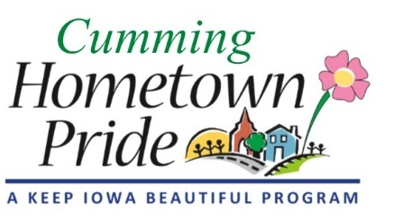
MINUTES
Cumming Hometown Pride
July 8 at 6:00 pm
Via Google Meet

Present via video call: Natasha, Shaunda, Lorin, Craig, Pat

June Minutes: No changes, approved

Water tower project update:
Final design is going to City Council for approval on July 13. Ben will be ordering the paint. The lift will be moved from Ben’s prior project to the park site. A tree next to the water tower will be trimmed. Angie is coordinating with Central Tank to get the base coat done. Ben plans to start July 27.

Fundraising:
Fridays at the Farm – we will set up a table/booth to solicit donations. Need to determine a schedule. Don’t participate until have the final agreement signed by City. Lorin to design and get made a 6 ft banner to hang from the table.

Local Businesses – city’s new website, go to Services/New Residents
Lorin will send her list of businesses, Shaunda will coordinate, everyone sign up to personally solicit/contact each business

The place we get our yard signs from can print shirts but not glassware. Advice – don’t skimp on quality of shirts.
Pat to talk to Angie if ok to have HTP website obtain payments/donations. Need to set up a square account.
Discussed the draft brochure and made suggestions. One was to change giving levels to Partner/Sponsor/Supporter.

Shaunda will look into adding the water tower mural as an event on the Great Western Trail website.

City Council Meeting: Committee discussed the information to present to the council on July 13.

Other business: Yard of the Month nominations need to be made by July 31.

Next meeting: August 3 at 6:00 pm at City Hall

